(Approx. 1,198 WORDS)

E-Mailing Photographs
By Richard Kennon, Editor, Amador Computer Users Group, CA
www.acug.net
Drtrdguy(at)volcano.net

Obtained from APCUG with the author's permission for publication by APCUG member groups.

First, we must understand that photograph (image) size in the camera and in the computer is measured in pixels. These are the basic dots of color that make the picture. Do not pay any attention to anything that says “inches” or “pixels per inch.” These terms are meaningless when we are considering a picture either in the camera or in the computer. They may come into play later if we want to print the photo on paper. But, that is another subject for another time. For now, we think only of pixels. Most cameras record too many pixels to e-mail. For instance a 6 megapixel camera will make a picture about 3000 pixels wide by 2000 pixels tall and the file size may be several megabytes. Our screens are usually only about 1000 pixels wide (some are larger and some smaller). So, if we e-mail the native picture, it will be wider than the screen for the recipient and the file will be so large, it may take “forever” to download to the recipient’s computer. It is possible the service provider will not even accept it.

There are two things we must do to make a photo e-mailable. The first is to resize or resample the picture. We want to change the picture width from 3000 pixels to 800 pixels, for instance. This process is called resizing or resampling. We have to pick the best 800 pixels out of the 3000 to represent our photo. Well, no, that is not exactly correct but it simplifies things to think of it that way. We don’t have to worry about it because a lot of very smart programmers have developed ways (algorithms) to help us. Just remember, you want to resize or resample to get the photo down to a size convenient for e-mailing. I usually use 800 pixels or 900 pixels width for pictures I attach to e-mails.
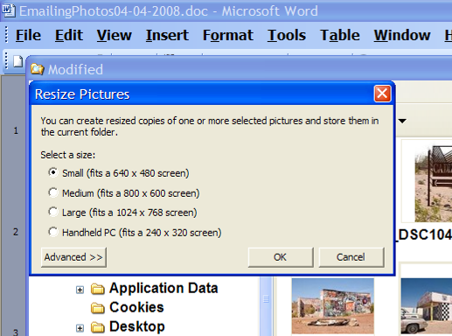
The second thing to do to make a photo e-mailable is to save it in JPEG format (.jpg). That is a format that reduces file size a lot and picture quality a little so the picture can be downloaded more quickly and still be nice to look at. Some software programs give you choices of compression amount with numbers ranging from 1 to 10. One will result in a very small file but the picture quality will not be good at all. A 10 will give the very best quality but with a very large file size. A reasonable compromise is to use 5 or 6. I usually use 6.

How do you do this? First, I will describe how to do it with a free Microsoft program. Then I will try to look at some other programs.

Microsoft Power Toys for XP has a Resize Pictures toy that is slick and easy but feedback says it only works on XP. It can be downloaded at http://www.microsoft.com/windowsxp/downloads/powertoys/xppowertoys.mspx. Right click on an image name or thumbnail in Explorer or My Computer and choose Resize Pictures. You are limited to four specific sizes but they are good choices. They don’t tell us what compression they are using but the results look OK. Unless you tell them under Advanced to replace the image in the file, it will make a copy. That’s good. They will add the word, “Large”, “Medium” or “Small” to the end of the name you have chosen.

If you are happy with this solution, then read no further. But, if you want to use a picture editing program, maybe this will help.

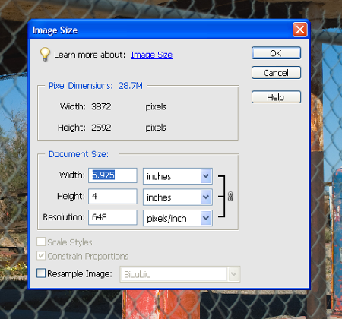
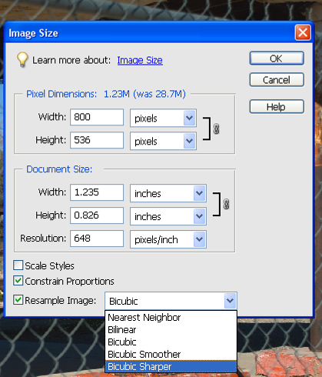
In Photoshop Elements 5, click on Image>Resize>Image Size and this window will pop up. Note that there is some garbage at the bottom about “inches” but we will ignore that. First we will click the Resample Image box. That puts the Pixel Dimensions in play and that is what we want. I selected the Width box and changed the width to 800 pixels. Since the Constrain Proportions box is selected, that is all I have to do.

Note, down at the bottom, that we have several choices of sampling algorithms. This is frosting on the cake. I read somewhere that I should use Bicubic Sharper when downsizing so that is what I do. Most programs don’t give us all these choices. Then we should click on File>Save As and give the photo a new name. I often just use the same name and add “_800px” so the next time I will know it is ready to e-mail. Here we can choose the JPEG format and the compression amount. Photoshop Elements 6 is out now and sells for about $100. If you are able to spend that much and want one of the best editing programs, I highly recommend it.
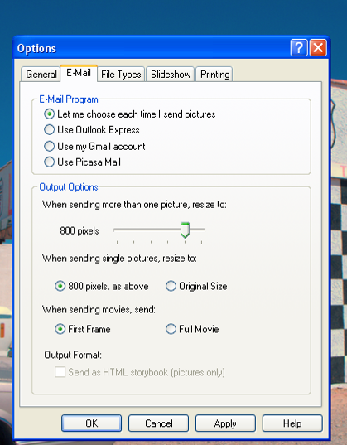
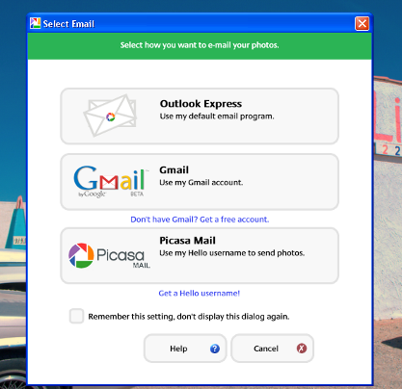
Let’s look at Picasa2. It is a free program from Google and looks really good but I do not have much experience with it. By all means, try it first because the price is right! When it comes to e-mailing photographs, it is a little more automated but not any easier to use than Elements. First, click on Tools>Options>E-Mail. Then select the width you want in pixels. There are six choices. Then click on Apply and OK.

The next step is to click on File>E-Mail and you will get three choices of how you want to e-mail your photos. Fortunately, I use Outlook Express so my choice is listed.

When I clicked on Outlook Express, an e-mail page popped up with the photo attached. At this point we can write something else on the e-mail and send it. I recommend this so the recipient will know it is really from you and not something sent out by a virus. When I receive e-mails that only say “Attached”, I Delete them without looking at the attachment. This saved me one time when I received a virus from my sister-in-law that she did not know she sent. She spent weeks and dollars getting her computer back up. Oh, I digress. If you want to send more than one picture (and, who doesn’t?), you must select the picture and click on the Hold button near the bottom of the screen. Do this for each photo you want to send and they will all be attached to the e-mail. The program automatically chooses JPEG format and a compression ratio but does not tell you. That is OK as the pictures I tried looked good. Picasa2 has considerable capability for editing photos in many respects. Try it!

There are many other editing programs that I haven’t mentioned and have no experience with. In all cases you want to change the picture’s size in pixels by resizing or resampling. Pay no attention to anything that says “inches” as that will have no meaning for this process. Sometime later we will talk about printing pictures and then we will use inches.

This article has been provided to APCUG by the author solely for publication by APCUG member groups. All other uses require the permission of the author (see e-mail address above).

